DISHES AND THEIR ALLERGEN CONTENT - TASTE OF SPICE – 2023.

DISHES | 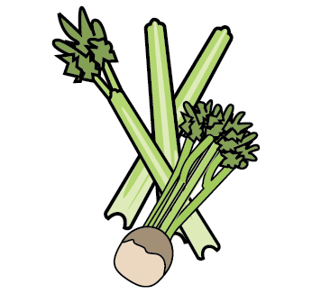 |  | 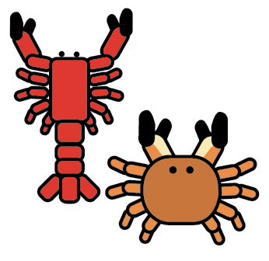 |  |  |  |  |  |  |  |  | 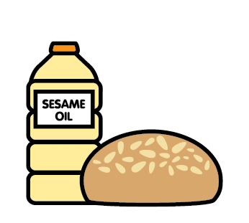 |  | 
 | Celery | Cereals containing gluten | Crustaceans | Eggs | Fish | Lupin | Milk | Mollusc | Mustard | Nuts | Peanuts | Sesame seeds | Soya | Sulphur Dioxide
Tuna Salad [example] | ✓ |  |  | ✓ | ✓ |  | ✓ |  | ✓
CHICKEN MASALA
TARKA DHAL
CHICKPEA & POTATO
TANDOORI CHICKEN
PUNJABI SAMOSA |  | YES
ONION & POTATO BHAJI’S
MINI NAAN BREAD |  | YES
POPPADOMS
WRAPS |  | YES

Review date: | 01/01/2024 | Reviewed by: | SUKH.CHUHAN |  | You can find this template, including more information at www.food.gov.uk/allergy

