|  |  |
| --- | --- |
| **REAL DAIRY ICE CREAMS**  ***60% Purbeck Milk & 22% Dorset Double Cream*** | **REAL FRUIT SORBETS**  ***Made with Purbeck Spring Water*** |
| * **Vanilla Bean** * **Honeycombe Hash** * **Mint Baby Choc Chip** * **Salted Caramel** * **Serious Chocolate** * **Lemon Ripple** * **Banoffee** * **Chocolate Orange** * **\*Cayenne Papper and Garlic on request** * **DAIRY FREE FLAVOURS** * **Chocolate and Raspberry** * **Vanilla** * **Rhubarb and Rosehip** | * **Mango** * **Raspberry** * **Cherry, Red Grape & Hibiscus** |
| **SERVED IN…** |
| * **Branded Recyclable Tubs** * **British Waffle Cones** * **British Gluten Free Cones** |
| **100% WHOLE FRUIT LOLLIES** |
| * **Strawberry** * **Gooseberry and Elderflower** * **Watermelon and Raspberry** |

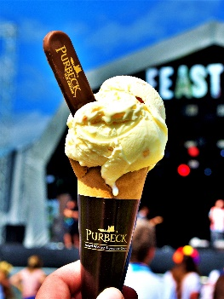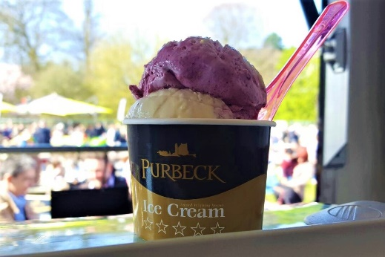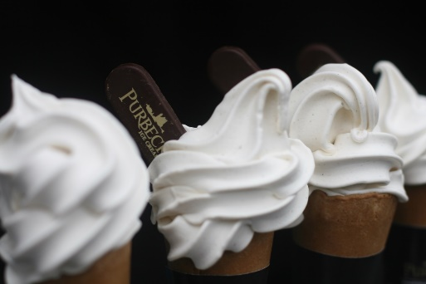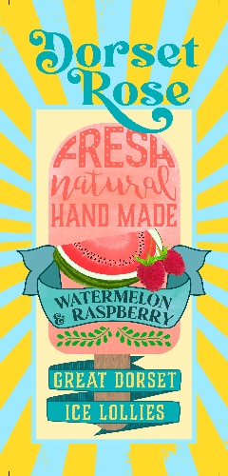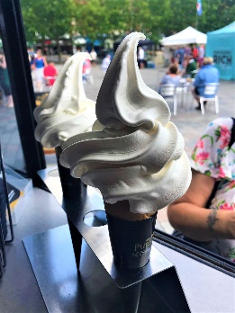

|  |  |
| --- | --- |
| **MENU ITEM** | **RETAIL PRICE** |
| **Single/Double Scoop** | **£4.00 - £6.50** |
| **Soft-whip Cream** | **£3.00 – 4.00** |
| **125ml Tub** | **£3.00 – 4.50** |
| **Whole-Fruit Lollies** | **£2.50 – 3.50** |